NOTES
Steps for the python codes for BCI applications
- Python library to connect with Neiry devices is located in the following folder: Capsule_and_API_2_0_40_19_09_2025\Capsule v2.0.40\CapsuleAPI\Windows\Capsule Python\CapsuleClientPython
- Files main.py and example.py show how to connect to the devices and receive the data.
- main.py contains snippets of code to receive all of the data from the device (emotions, indices, MEMS, PPG in addition to EEG).
- example.py is a simplified version of main.py script. It may be easier to understand the code in example.py but if you need some specific indices you may look at how to receive them in main.py.
Steps for EEG and microphone usage
- Here are python scripts to record EEG and microphone simultaneously. In these scripts the recording from microphone and Neiry device are started and stopped simultaneously and the resulting recordings are saved into two separate files in the folder named "data".
- Neiry_headband.py is used to connect with the headband, and neiry_headphones.py is used to connect with the headphones.
- Note, the script will use the microphone which is set by your OS as default (i.e. in windows you may choose the microphone from the headphones in the settings system => sound => input)
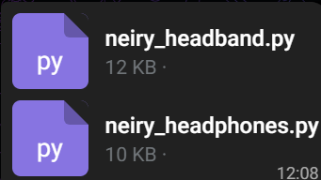
To connect with the devices, these scripts use the following python library:
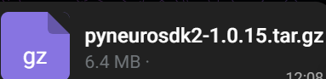
In case if you have troubles with the python scripts, I also prepared the .exe files. You may just run them without installation of python or any of the python libraries. The .exe will create "data" folder and save the recordings in there.

